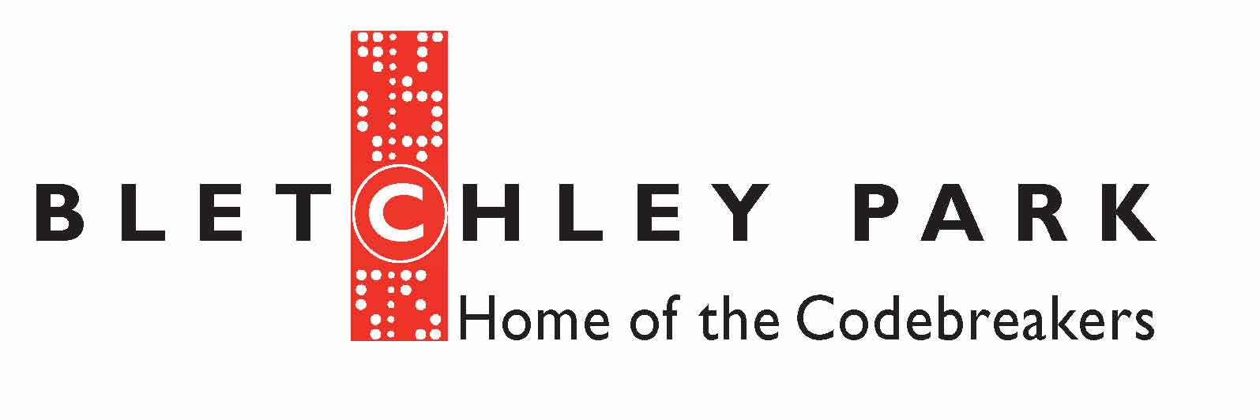

ENIGMA CODEBREAKER TALKS
The REAL Enigma Machine from Bletchley Park will be at Bude at War. The sessions will be held at Bude Surf Life Saving Club ( aka “Bletchley”) on SATURDAY 16th September only. There are four time slots with only 30 seats available per session. Due to the cost of being able to bring the Enigma Machine and mathematician Thomas Briggs to our event, tickets can be bought for £10 per person. We hope that you will enjoy this fascinating introduction to the history of and how to break ciphers.
ABOUT YOU: Please let us have all details so we can contact you
LEAD NAME: ___________________________________________ TEL NO: ________________________
EMAIL ADDRESS: _______________________________________________________________________
ADDRESS: _____________________________________________________________________________
______________________________________________________ POST CODE _____________________

TICKETS and SESSION TIMES
Each talk is one hour long with 15 minutes for Q&A.
 | Time | Preferred Choice /No of tickets | Second Choice / No of tickets
1 | 10am -11.15am
2 | 11.30am -12.45pm
3 | 1.30pm-2.45pm
4 | 3.30pm-4.45pm
Please tick the talk you would like to go to stating your first option and in the event of talks being fully booked, your second choice. Thank you

PAYMENT to be sent by cheque with a stamped addressed envelope, thank you.
No of tickets ________ x £10pp _____________ Cheques made payable to Bude At War.

Signature______________________________________________ Date ______________________
Please send signed forms to Bude At War, 20 Priestacott Park, Kilkhampton, Bude, Cornwall EX23 9TH .

OFFICE USE ONLY:
Date received________ Ticket Number issued _______________________________________ Tickets sent ____________

